**Coffee Shop Sales Report**

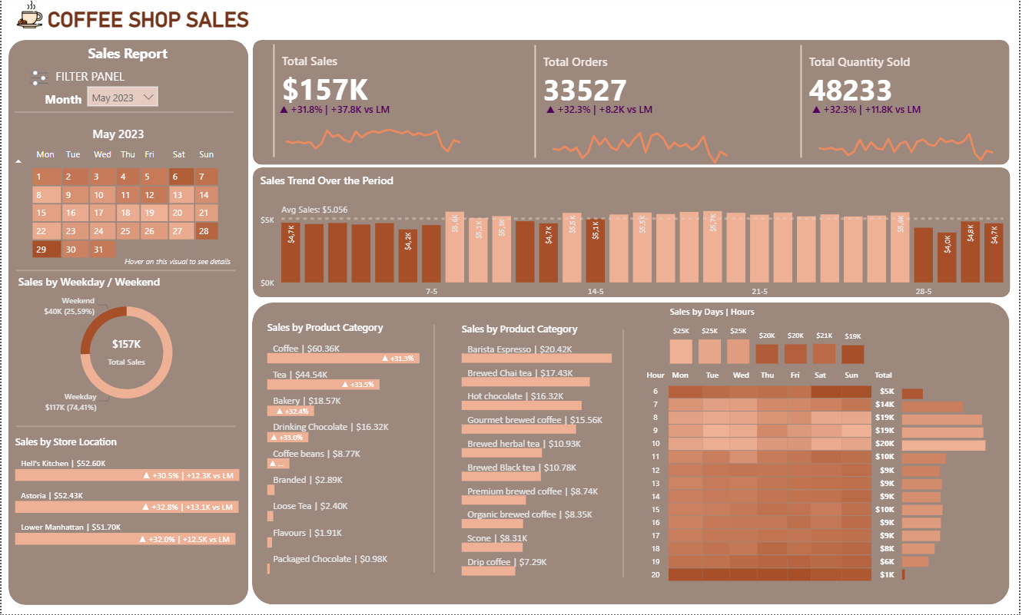

DAX Code

DATE TABLE

**Date Table** = CALENDAR(MIN(Transactions[transaction_date]), MAX(Transactions[transaction_date]))

**Month** = FORMAT('Date Table'[Date], "mmm")

**Month Year** = FORMAT('Date Table'[Date], "mmm yyyy")

**Day Name** = FORMAT('Date Table'[Date], "DDD") 📝type the first 3 letters of the day name

**Week Number** = WEEKNUM('Date Table'[Date], 2) 📝 wich day of the week I want to star a new week (2=Monday)

**Day Number** = FORMAT('Date Table'[Date], "D") 📝number for each day of the month – from 1 to 30/31

**Week Day Number** = WEEKDAY('Date Table'[Date], 2) 📝number of each day of the week – from 1 to 7

**Weekday / Weekend** = IF('Date Table'[Day Name] = "Sat" || 'Date Table'[Day Name] = "Sun", "Weekend", "Weekday") 📝Distinct Weekday and Weekends

**KPIS**

--SALES

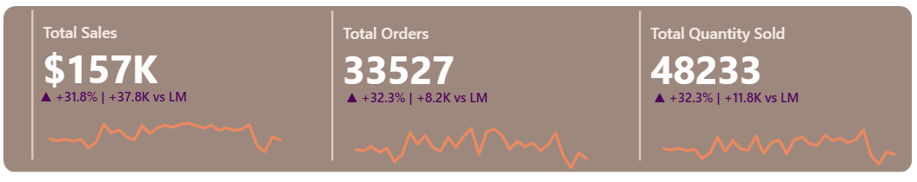

**Sales** = Transactions[unit_price] * Transactions[transaction_qty]

**Total Sales** = SUM(Transactions[Sales])

**CM Sales** = VAR selected_month = SELECTEDVALUE('Date Table'[Month])

    RETURN

    totalmtd(CALCULATE([Total Sales] , 'Date Table'[Month] = selected_month), 'Date Table'[Date])

**PM Sales** = CALCULATE([CM Sales] , DATEADD('Date Table'[Date], -1, MONTH))

**MoM Growth & Diff Sales** =

    VAR month_diff = [CM Sales] - [PM Sales]

    VAR mom = ([CM Sales] - [PM Sales])/ [PM Sales]

    VAR _sign = IF(month_diff > 0, "+", "")

    VAR _sign_trend = IF(month_diff > 0, "▲", "▼")

    RETURN

    _sign_trend & " " & _sign & FORMAT(mom, "#0.0%" & " | " & _sign & FORMAT(month_diff/1000, "0.0K")) & " " & "vs LM"

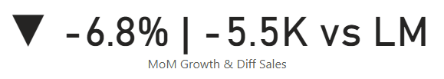

--ORDERS

**Total Orders** = DISTINCTCOUNT(Transactions[transaction_id])

**CM Orders** = VAR selected_month = SELECTEDVALUE('Date Table'[Month])

    RETURN

    totalmtd(CALCULATE([Total Orders] , 'Date Table'[Month] = selected_month), 'Date Table'[Date])

**PM Orders** = CALCULATE([CM Orders] , DATEADD('Date Table'[Date], -1, MONTH))

**MoM Growth & Diff Orders** =

    VAR month_diff = [CM Orders] - [PM Orders]

    VAR mom = ([CM Orders] - [PM Orders])/ [PM Orders]

    VAR _sign = IF(month_diff > 0, "+", "")

    VAR _sign_trend = IF(month_diff > 0, "▲", "▼")

    RETURN

    _sign_trend & " " & _sign & FORMAT(mom, "#0.0%" & " | " & _sign & FORMAT(month_diff/1000, "0.0K")) & " " & "vs LM"

--QUANTITY

**Total Quantity Sold** = SUM(Transactions[transaction_qty])

**CM Quantity** = VAR selected_month = SELECTEDVALUE('Date Table'[Month])

    RETURN

    totalmtd(CALCULATE([Total Quantity Sold] , 'Date Table'[Month] = selected_month), 'Date Table'[Date])

**PM Quantity** = CALCULATE([CM Quantity] , DATEADD('Date Table'[Date], -1, MONTH))

**MoM Growth & Diff Quantity** =

    VAR month_diff = [CM Quantity] - [PM Quantity]

    VAR mom = ([CM Quantity] - [PM Quantity])/ [PM Quantity]

    VAR _sign = IF(month_diff > 0, "+", "")

    VAR _sign_trend = IF(month_diff > 0, "▲", "▼")

    RETURN

    _sign_trend & " " & _sign & FORMAT(mom, "#0.0%" & " | " & _sign & FORMAT(month_diff/1000, "0.0K")) & " " & "vs LM"

**CHARTS**

--CALENDAR HEAT MAP

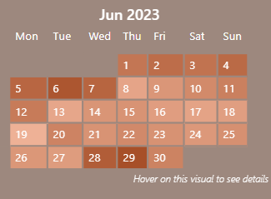

Use Matrix selecting Week Number (Rows), Day Name (columns) and values (Date Table).

To order day names, select it and click on Column tools/Sort by.

Design your chart color preferences. Gradient color panel is defined by Visual/Cell Elements.

--HOVER

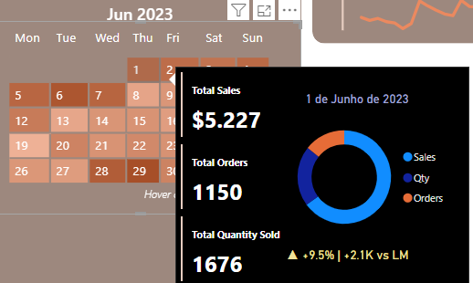

Creat a new page Format your new page/Canvas setting/Type/Tooltip.

Choose the charts and information that you want to launch. In the end select the calendar heat map search for tooltip/options/page/name of your page.

--SALES BY WEEKDAY/WEEKEND

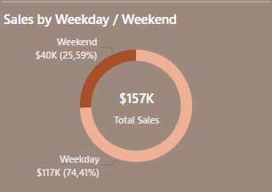

Use donut chart: Legend = Weekday/weekend and Values = Total Sales

In the middle place a simple card with Total sales.

--SALES BY STORE LOCATION

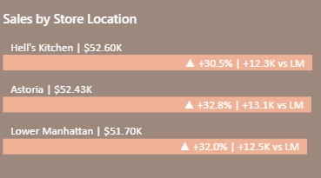

Use cluster bar chart; Y Axis = store_location, X Axis = Placeholder + Total Sales

**Placeholder** = 0

Create Label for Store Location

**Label for Store Location** = SELECTEDVALUE(Transactions[store_location]) & " | " & FORMAT([Total Sales]/ 1000, "$0.00K")

Use it in Visual/Datalabels/Value/Field/Label for Store_location

--SALES TREND OVER THE PERIOD

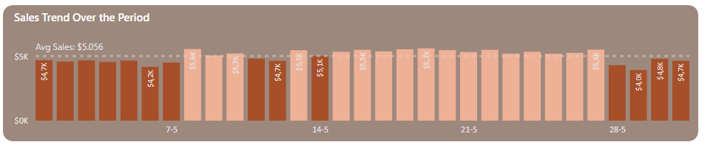

Use Stacked column chart: X axis= transaction_date, Y axis = Total Sales.

Create Daily Avg Sales

**Daily Avg Sales** = AVERAGEX(ALLSELECTED(Transactions[transaction_date]), [Total Sales])

And place it in 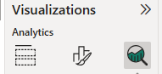 Y Axis Constant Line/apply settings to/Daily AVG Sales (rename it)

For conditional formatting create color for bars

**Color for Bars** = IF([Total Sales]>[Daily Avg Sales], "Above Average", "Below Average" )

And place it in Visual/columns/Color

--SALES BY DAYS | HOURS

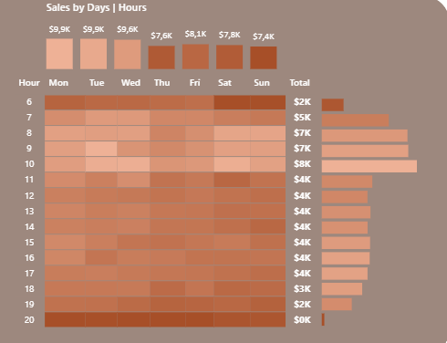

Use Matrix: Rows = Hour, Columns = DayName, Values = Total Sales.

**Hour** = HOUR(Transactions[transaction_time])

Style should be: None

Fill the Cell elements with conditional formatting colors for background and fount colors.

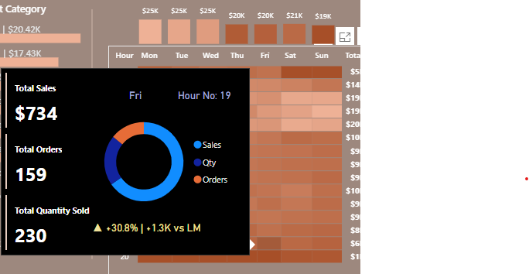

Apply **Tool Tip** (see info in HOVER), add new page, create Hour No.

**TT For Hour** = "Hour No:" & " " & FORMAT(AVERAGE(Transactions[Hour]), 0)

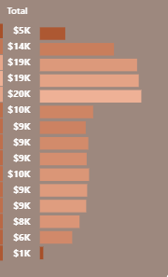

Use stack bar chart; Y-axis = Hour, X-axis = Total Sales .

To invert order from Hour go to Visual/Y-axis/invert range ✔️

Use the same formatting color and place the chart in the right place, to match the hours from matrix chart.

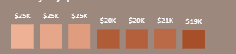

Use stack columns chart; Y-axis = Day Name, X-axis = Total Sales .

Use the same formatting color and place the chart in the right place, to match the hours from matrix chart.

To ensure interactions between all charts, edit interactions and check filter interactions. Manage your preferences as needed.

All rights reserved to:  
🙌 Data Tutorials

💻Link: https://www.youtube.com/watch?v=_JwAryp3STM